Ambulance Call by Jacob Lawrence
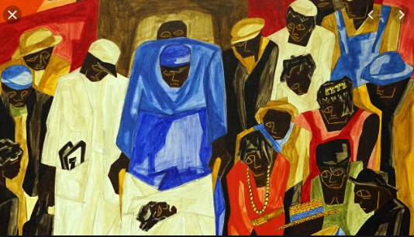
Introduction
“Ambulance Call” is a painting done by Jacob Lawrence in 1948 with a size of 24 x 20 inches (61 x 50.8 cm). The medium of the art is a tempera on board and the art is now located in Crystal Bridges Museum of American Art, Bentonville, Arkansas. It depicts the African American culture of Harlem Renaissance in a period where cultural collaboration and richness redefined how people demonstrated their experiences through literature, music, and art. At the time when this painting was done, Harlem Hospital was of the few health facilities that attended to black patients in New York City. Consequently, the sick blacks had to wait for significantly longer times before seeing a physician that their white counterparts. Painting depicts a scene where ambulance attendants are lifting a stretcher with an ailing body covered in white sheets while a paramedic is beside the victim monitoring his/her condition as they wait to see a physician. The three people are surrounded by spectators whose sad expressions and downcast eyes suggest that they are barely anonymous onlookers but are neighbors, friends, and family of the ailing person. The painting displays the plight of the African American in accessing healthcare in the 1940s.
Ekphrasis
Lawrence has immensely used lines to develop the various aspects of the painting. There are horizontal that gives the transition of distance in the art as the on-lookers appear a distant away from the ill person. Some of the lines appear jagged thereby depicting emotional turmoil and anxiety as the on-lookers and the paramedic wait in line to see a paramedic. The artist used jagged lines to portray emotional grief in the desolate community due to their ailing healthcare system that discriminated against the African Americans.
The painting depicts application of two-dimensional shape in geometric forms with the flat outline of the human shapes brought to life by color tones. The artist attempts to define depth and form using different colors and forms in the painting with warm colors appearing to advance while cool colors recede. The shapes are abstract thereby allowing Lawrence to generate a unique art piece that require detailed visual analysis to convey meaning. The shapes of the painting are fractured to depict emotional torture of friends and family members of the ill person, as they wait for him/her to be attended by a doctor.
There is an exceptional use of texture in the painting to depict depth and dimension. There is something so sublime about this painting; it is like a fever dream. Lawrence uses texture as a stylistic choice of his nonrepresentational abstract painting to craft his vision. He has combined both rough and smooth texture to elicit attention in different areas of the painting. For instance, there is a smooth texture in the depiction of the on-lookers as the author seeks to highlight their emotional faces.
Depth and perspective have been highlighted in the painting through the use of flagged thin lines and geometrical shapes. The artist also contrasts between light and dark colors to give a sense if depth in the painting. While the ambulance attendants, the paramedic, and the ill person appear in close view, the rest of the people in the painting are on the background with the contrasting colors and picture lines allowing an observer to discern the distance between the two groups of individuals. He has also achieved depth by drawing objects that are close on the lower level and raised them as they become distant from view.
Lighting has been used to give structure and meaning to the painting. The use of dark lighting on the faces of the characters in the painting depicts their African American race as well as the gloom surrounding the scene being depicted by the painting. The use of both bright and dull colors differentiate the lighting of the painting thereby allowing the viewer to perceive what the main theme of the painting by discerning the light areas, for instance, the use of white lighting to depict the lab coats of the ambulance attendants and the paramedics. Lighting has also been used to enhance the depth of the painting by appearing bright on the front view and fading as one transitions in to the background. The part of the painting with a smooth texture have made use of light colors while the rough areas are flanked by dark colors thereby allowing to differentiate the textures in the various regions of the painting.
Naturalism has subtly been applied in the painting as the artist makes use of human figures with the message depicted in the art requiring maximum analysis of all its parts by an observer. The individual characters in the painting are depicted as helpless but they are motivated by the strong instinctive drives from within and beleaguered by social and economic burdens from without. As such, they have little will or responsibility for their fates, and the forecast for their cases is viewed with pessimism from the onset. The use of this style in the painting depicts disturbed people who still have hopes in the system despite its failure to attend to their welfare in fairness.
Analysis

